| **Title:** Testing Report for "ansh.webnetis.com" **Prepared by:** Ansh Bakshi  **Date:** 10-10-2024  **Website 1:** [**https://ansh.webnetis.com/**](https://ansh.webnetis.com/) **(React-based website)** |
| --- |

Testing Websites as a QA Engineer:

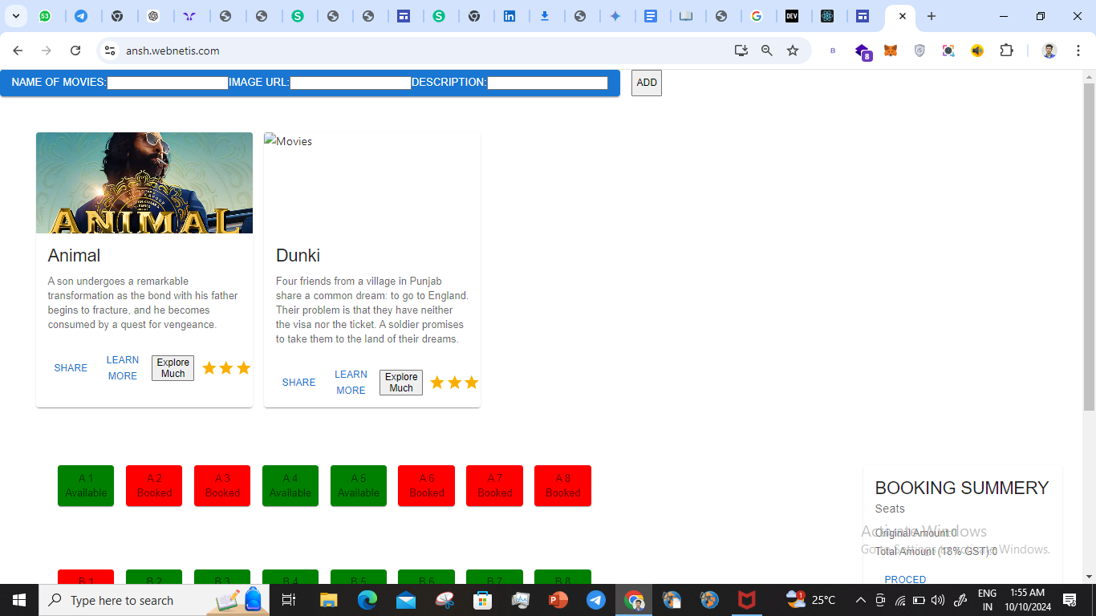

**Website 1:** [**https://ansh.webnetis.com/**](https://ansh.webnetis.com/) **(React-based website)**

**Test Cases and Scenarios:**

| Feature | Test Case | Expected Behavior | Potential Defect |
| --- | --- | --- | --- |
| **Homepage** | Access the homepage | Homepage loads correctly with all content displayed | Broken images, missing sections |
| **Navigation** | Click on navigation links | User is redirected to the corresponding page | Broken links, incorrect redirection |
| **Contact Form** | Fill out the contact form with valid data | Form submission is successful, confirmation message appears | Form validation errors, unsuccessful submission |
| **Responsiveness** | View the website on different devices (desktop, mobile, tablet) | Website elements adapt and display correctly | Layout issues, content overlapping |

### Testing Plan for "ansh.webnetis.com"

#### 1. Black-Box Testing

* **Actions:**
  + We navigated through all pages and checked if buttons and links work as expected. // But “explore much button”, “Proceed button” were not working and the image was missing from the webpage”
  + We filled out all forms on the site and submitted to ensure correct processing // as the database is not connected to the webpage so after every refresh the information stored gets clear.
  + By Checking the navigation menu, including any dropdowns or sub-menus.// the seat selection buttons were working properly ,
  + By Viewing the site on multiple devices and checking responsiveness.// the Website layout could not adapt to mobile devices.

**Defects**

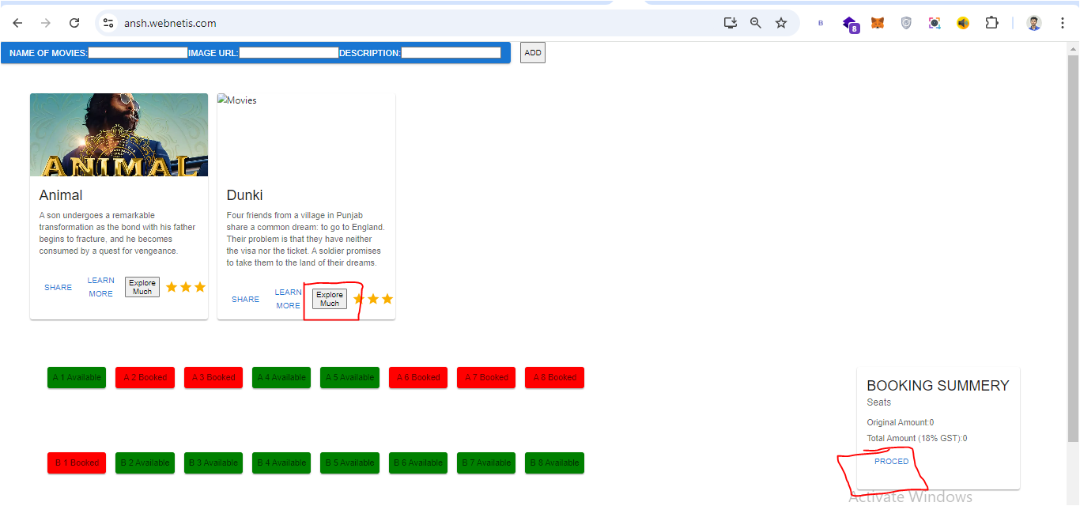

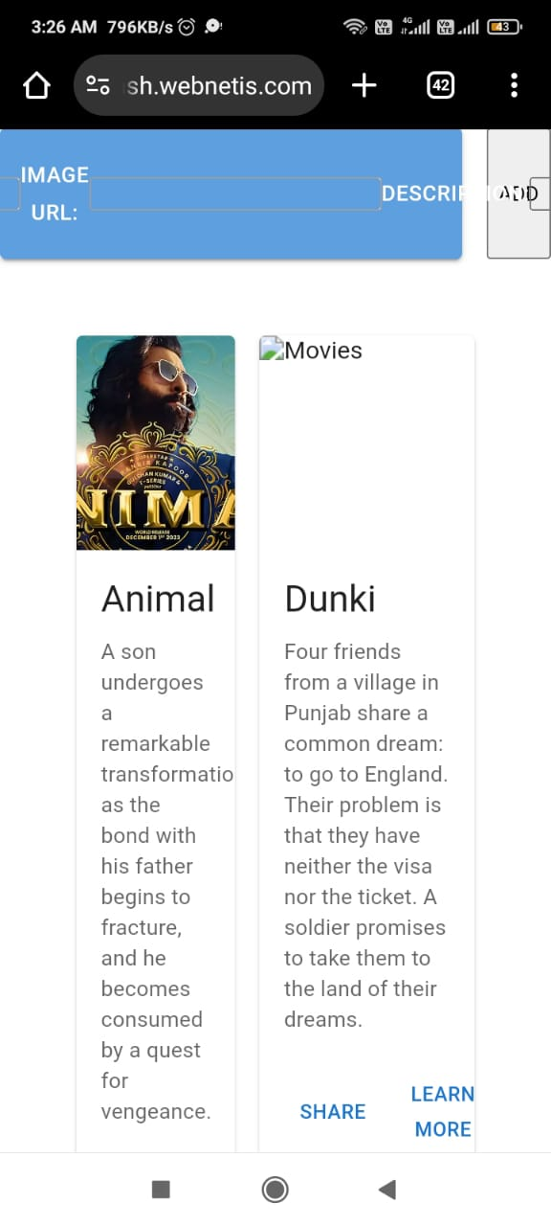

#### 

#### 

#### 2. Functional Testing

* **Actions:**

We tested all forms and user inputs, ensuring data validation and submission.// when a user puts in some irrelevant information it still takes it

.

If any modals or pop-ups appear, ensure they display and close correctly.

We tested API calls to ensure data retrieval, display, and any CRUD (Create, Read, Update, Delete) operations are possible or not // But it failed to retrieve image from the link of code

* **Defects**

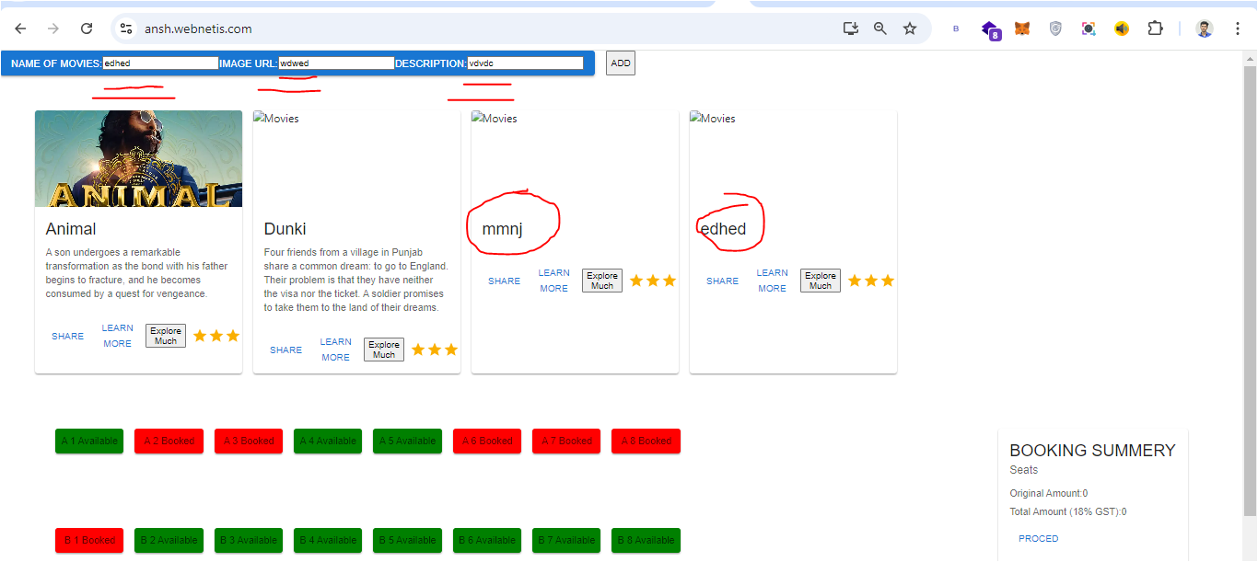

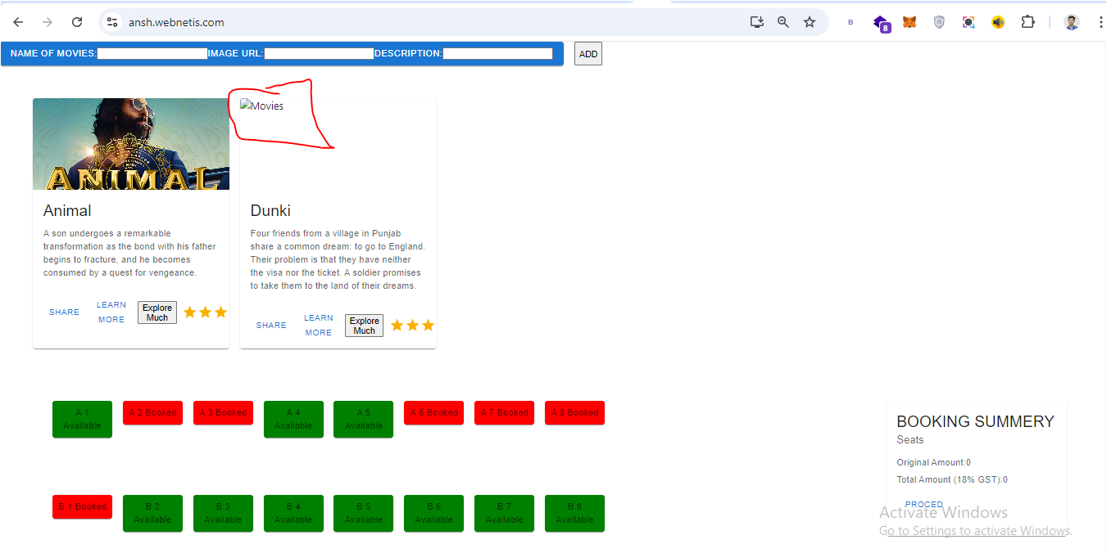

#### 

#### 

#### 3. White-Box Testing

* **Actions:**
  + We review the website's code and check for logical errors, unnecessary loops, and data flow issues//but the code was correct .
  + 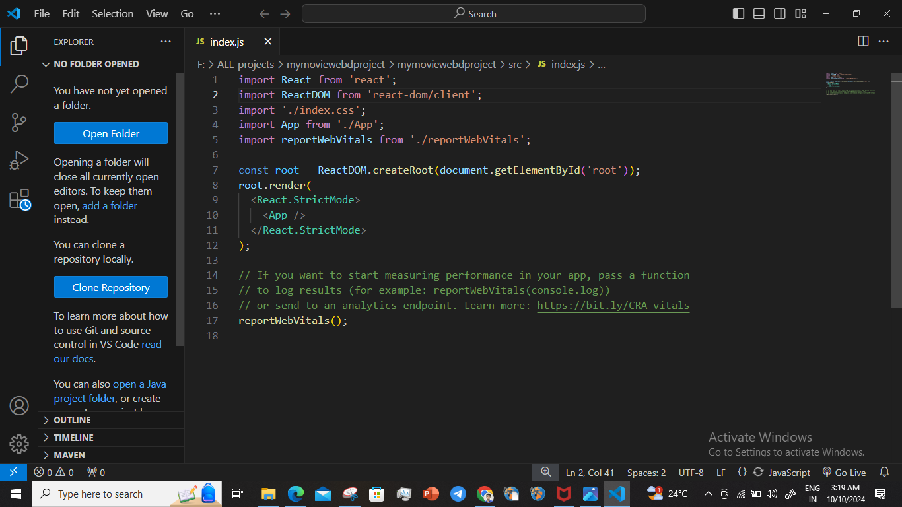

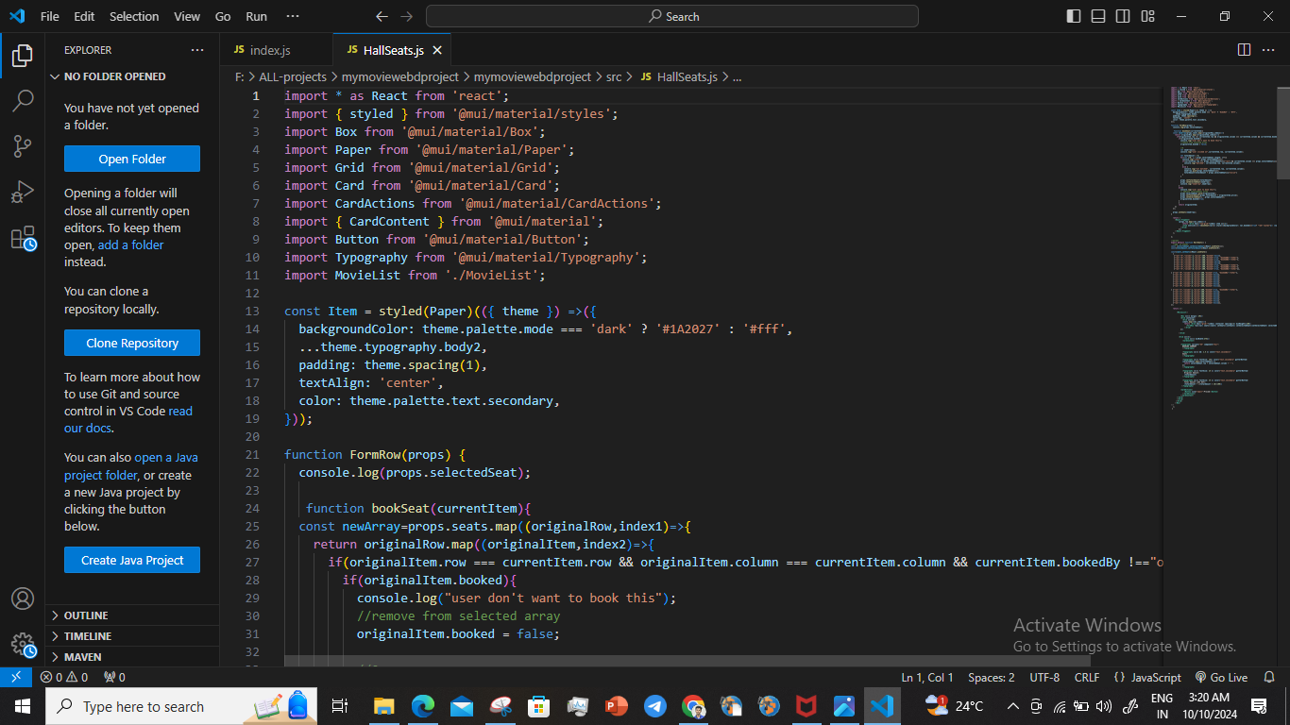

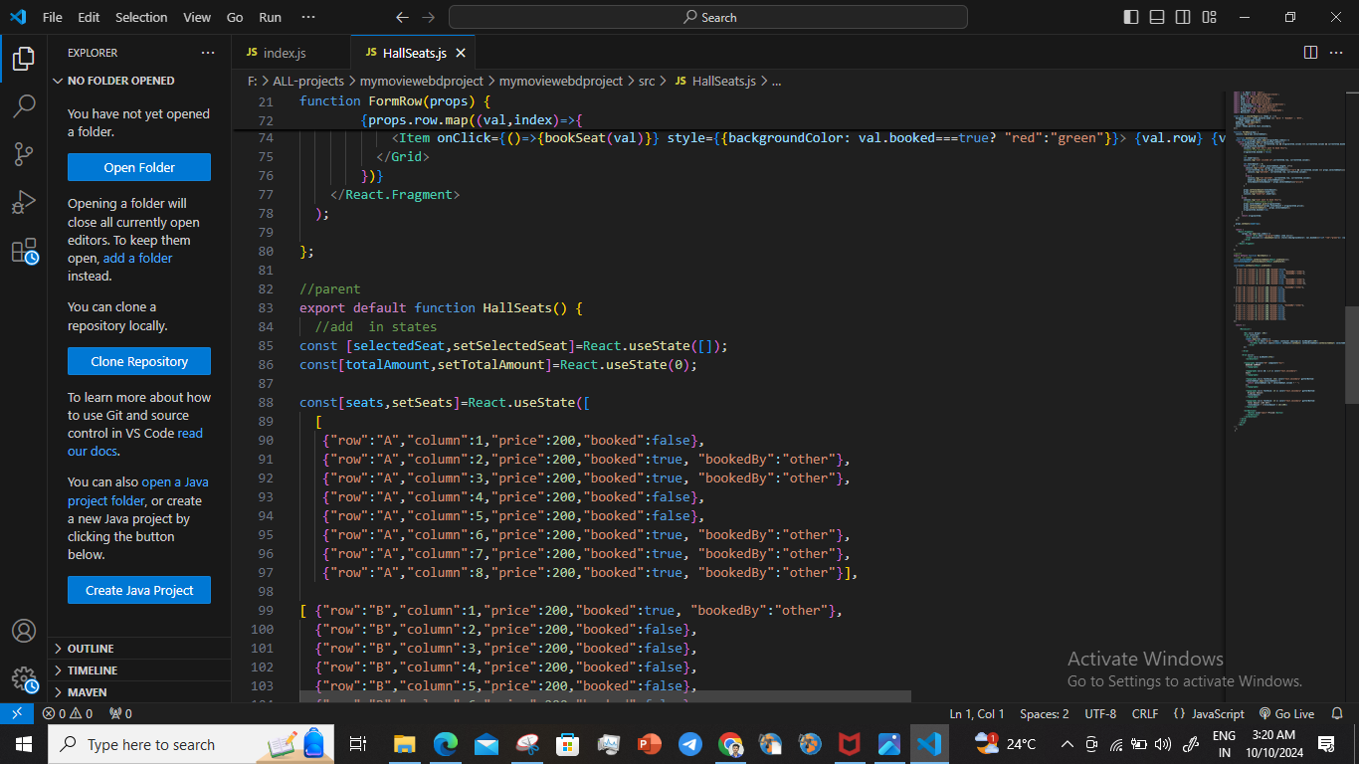

#### 

#### 

#### 4. Unit Testing

* **Actions:**
  + We tested individual components, such as React components and JavaScript functions, in isolation. // they performed well
  + Check each CSS class to ensure consistent and expected styling. //the css styling need to made effective white background could be enhanced

#### Unit Testing for different source-code files

### 1. HallSeats.js

#### Unit Testing

* **Component Functionality**:
  + **Selected Seat Logic**: The bookSeat function handles booking and unbooking seats. This logic works correctly, as it updates the state based on user interactions.
  + **Seat Availability Display**: The conditional rendering of seat availability (red for booked, green for available) functions as expected.
* **CSS Styling**:
  + **Enhancement Suggestion**: Implement a consistent styling approach for seat states. Consider adding hover effects to improve user experience. Additionally, a white background for the overall layout could enhance visibility.

### 2. Home.js

#### Unit Testing

* **Rating Display**:
  + The Rating component from Material UI is correctly set up to display a static rating. The implementation appears functional.

### 3. Layout.js

#### Unit Testing

* **Outlet Functionality**:
  + The Outlet component effectively allows for nested routes, which is a standard practice in React Route

### 4. MovieList.js

#### Unit Testing

* **State Management**:
  + The addMovie function and the input handling for movie details work as expected. However, consider validating user inputs to prevent incorrect data entry.

### 5. reportWebVitals.js

#### Unit Testing

* **Functionality**:
  + The function correctly imports and utilizes the web-vitals library to log performance metrics.

### 6. setupTests.js

#### Unit Testing

* **Configuration**:
  + The setup correctly configures Jest to use @testing-library/jest-dom.

#### 5. Integration Testing

* **Actions:**
  + Test interactions between components to ensure smooth data flow and functionality. //inside code there was an very easy encapsulation and code ran successfully
  + We verified API integration with the UI and ensured accurate data presentation.
* 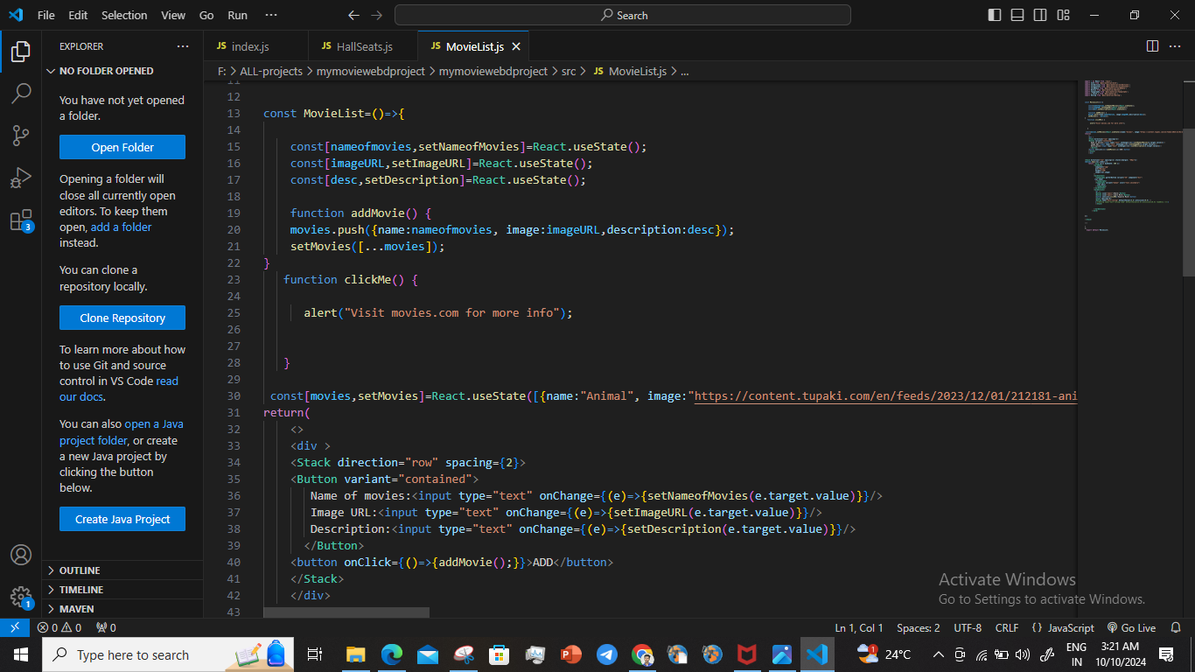

#### Integration Testing for different source files

1. **HallSeats.js**

#### Component Interaction:

#### The FormRow component interacts seamlessly with the HallSeats component, managing seat selections effectively.

#### State Management:

#### The use of useState to manage seat bookings and the total amount works well, ensuring data flows smoothly between the components.

### 2. Home.js

#### Integration Testing

#### Component Interaction:

#### Since this component primarily displays static content, there are no interactions to test. However, ensure it integrates well within the overall application layout.

### 3. Layout.js

#### Integration Testing

* **Routing**:
  + Check that the layout integrates smoothly with the rest of your application, especially ensuring that nested routes render correctly within the layout.

### 4. MovieList.js

#### Integration Testing

* **Component Interaction**:
  + The interaction between the input fields and the state management for movie lists functions smoothly. The Rating component is well integrated and appears within the card layout.
* **API Integration**:
  + Ensure that if you later add API functionality, the state reflects the fetched movie data accurately.

### 5. reportWebVitals.js

#### Integration Testing

* **Performance Monitoring**:
  + Make sure this file correctly hooks into your app’s lifecycle to capture metrics.

### 6. setupTests.js

#### Integration Testing

* **Testing Library Integration**:
  + Ensure that the custom matchers work effectively with your tests.

#### 

#### 

#### 6. System Testing

* **Actions:**
  + We simulated real-world user flows such as registration, login, and form submission.// No facility available for user to put query,or register,or proceed for payment integrated
  + Test different user roles, if applicable, and validate access control.// the website was accessible by any person,but there should be access control policy
* **Defects:- user login page,user query page,payment pageNot available** 
  + 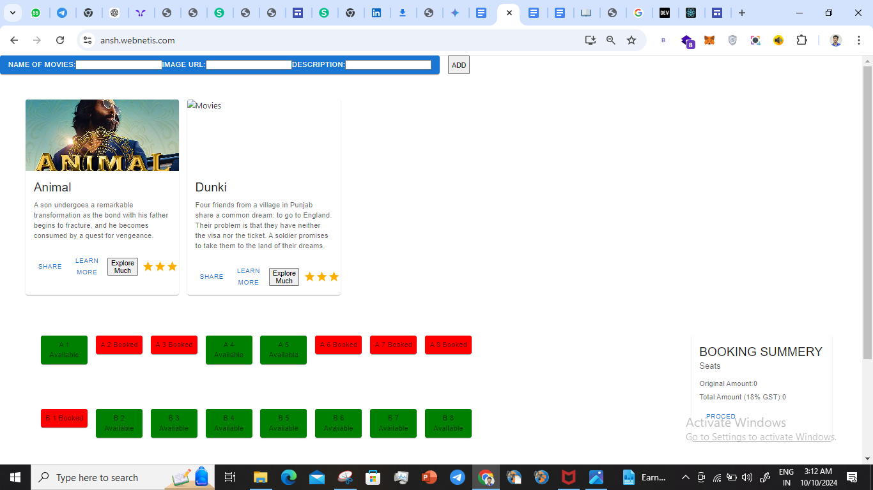

#### 7. Performance Testing

* **Actions:**
  + We Measured page load times across devices and network speeds. // Average 5G (50-100 Mbps): Between 1-2 seconds for a full page load.

Fast 5G (100+ Mbps): Often under 1 second, particularly for optimized pages.

#### 8. Usability Testing

* **Actions:**
  + We navigated the website from the user perspective to assess intuitiveness. // the background could be enhanced,more of more features could be added ,could be made to work compatible with cell phone
  + // The seat no’s could be made bold for proper visibility

#### 

#### 

#### 9. Compatibility Testing

* **Actions:**
  + We test the website on different browsers (Chrome, Firefox, Safari) and devices.// and the webpage was working seamlessly on every browser
  + Check layout and functionality on different operating systems.// it gave same page on different Browser
* 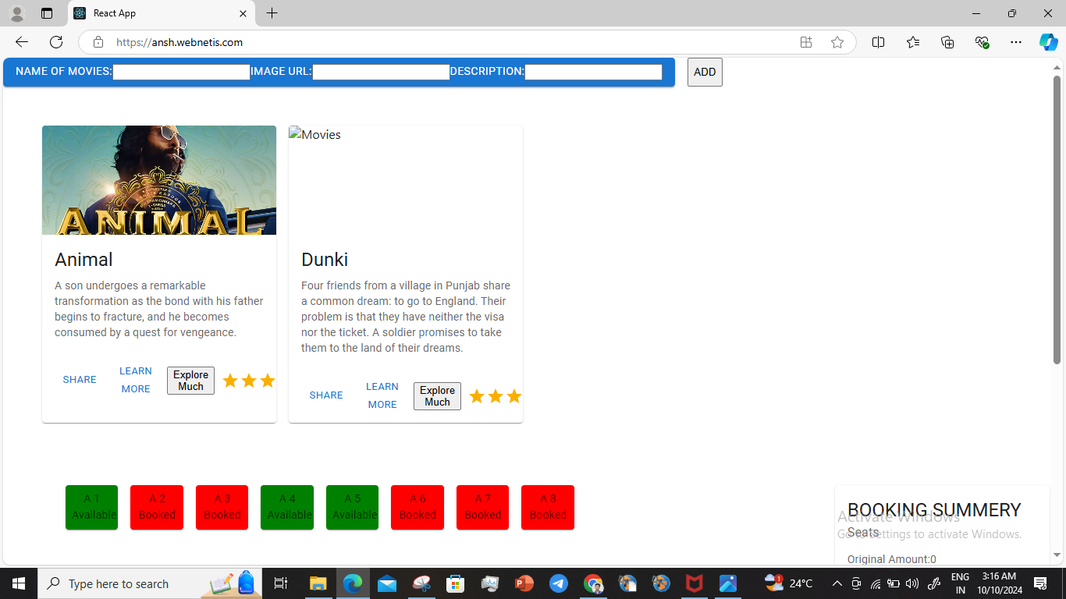

#### 10. Load Testing

* **Actions:**
  + We simulated high traffic conditions to assess how the server handles concurrent requests.// but it was able to handle multiple request and was not lagging the speed to adapt user input

#### 11. Stress Testing

* **Actions:**
  + We increased traffic beyond typical levels to test stability under extreme conditions.// but the webpage worked efficiently
  + We evaluated system recovery time after high traffic spikes.//and was able to perform well in high traffic also

#### 12. Scalability Testing

* **Actions:**
  + We gradually increased user load to assess how the system scales. //it was scalable,consistent, durable

**Additional Considerations:**

* **Performance Testing:** We Measured website loading times and responsiveness on different internet speeds it was satisfactory
* **Security Testing:** We Ensured that the website uses HTTPS and has secure data handling practices.

**Source Code link :-** <https://github.com/iamanshbakshi/mymoviewebdproject/commit/abc206e0a952a47e0fef9422450afe1641f6a830>